*ecse 211 design project*

Testing Document

Version *1.00*

*01/03/2018*

*ECSE 211 TEAM 11*

VERSION HISTORY

|  |  |  |  |  |
| --- | --- | --- | --- | --- |
| **Title** | Testing Document | | | |
| **Description** | Test the built system if meets all the requirements | | | |
| **Created By** | Tianyi Zou, Testing leader | | | |
| **Date Created** | 1st March 2018 | | | |
| **Version Number** | **Modified By** | **Modifications Made** | **Date Modified** | **Status** |
| 1.00 | Tianyi Zou | Created the Testing Document Template | 1st March | Preliminary version of the document;  added testing template |

TABLE OF CONTENTS

# 1 Hardware Testing

1.1 Ultrasonic Sensor

1.2 Light Sensor

1.3 Motors

1.4 Wheels

1.5 Robot Structure

# 2 Software TESTING

2.1 Localization

2.2 Navigation

2.3 Obstacle Traversal

2.4 Search area

2.5 Capture

2.6 Obstacle avoidance

2.7 Wi-fi Integration

# 3 Integration testing

# 4 Test report templates

# 5 Test Reports

# 5 Test report templates

# Testing template

**Test’s Title:____________________**

**Tester’s names:___________________________________ Test Date:________________________**

**___________________________________ Software Version:__________________**

**___________________________________ Hardware Version:_________________**

**___________________________________**

**Test Code/Number: _________________________**

**Objective:**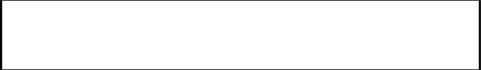

**Background knowledge (if needed):**

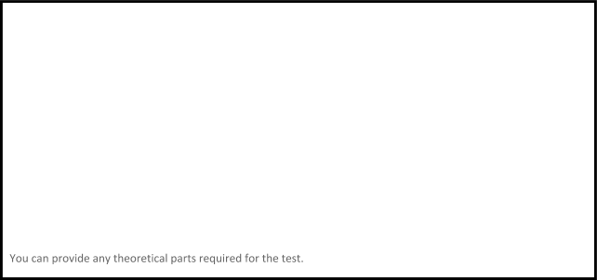

**Procedure:**

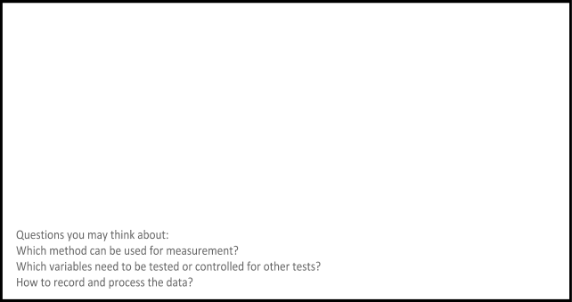

**Expected Results:**



**Test Report:**

|  |  |  |  |  |  |  |
| --- | --- | --- | --- | --- | --- | --- |
| **Tests** | **Variables** | | | | **Passed?** | **Comments:** |
|  |  |  |  |  |
| **1** |  |  |  |  |  |  |
| **2** |  |  |  |  |  |  |
| **3** |  |  |  |  |  |  |
| **4** |  |  |  |  |  |  |
| **5** |  |  |  |  |  |  |
| **6** |  |  |  |  |  |  |

**Conclusion/Action/Distribution**

